OBJECTIVES:
- To write a program to perform bit manipulations.

MATERIAL:
- Atmel Studio

WEB SITES:
- www.microchip.com for Atmel Studio Software

ACTIVITY 1
Write a program that copies bits 1, 2, and 3 of PIND to bits 0, 1, and 2 of port B.
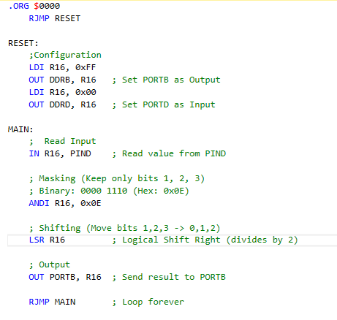

ACTIVITY 2
Write a program that copies bits 1 and 6 of PINC to bits 0, and 2 of port B, respectively.
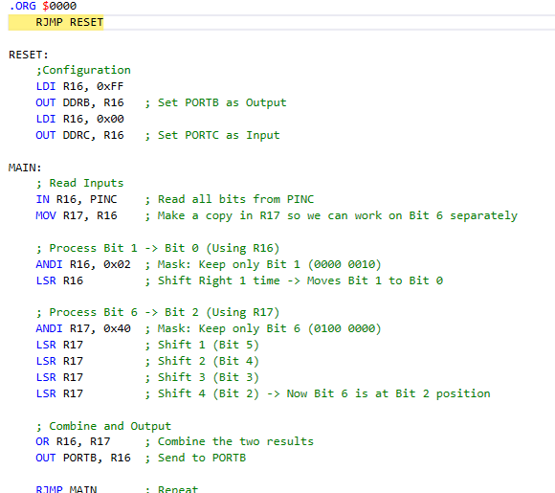

ACTIVITY 3
- Write a program that inverts bit 3 of port C and sends it to bit 5 of port B.
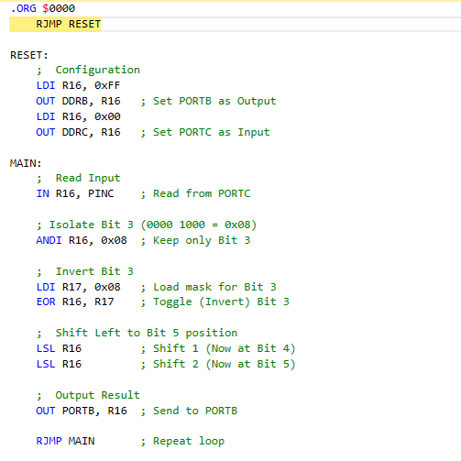

- Find the value in R16 after the following code.
LDI R16, $45
ROR R16
ROR R16
ROR R16
R16 = $48 in hex
Initial State
- Instruction: LDI R16, $45
- Hex $45 in Binary: 0100 0101
- Carry Flag (Initial): Assume $C = 0$ (default).

Step-by-Step Rotation
The ROR instruction shifts all bits one position to the right. The bit that "falls off" the right side (Bit 0) moves into the Carry flag, and the current value of the Carry flag moves into the left side (Bit 7).
1st ROR Operation
- Before: 0100 0101, $C = 0$
- Process: Bit 0 ($1$) moves to $C$. Current $C$ ($0$) moves to Bit 7.
- Result: 0010 0010, $C = 1$ (Hex: $22)
2nd ROR Operation
- Before: 0010 0010, $C = 1$
- Process: Bit 0 ($0$) moves to $C$. Current $C$ ($1$) moves to Bit 7.
- Result: 1001 0001, $C = 0$ (Hex: $91)
3rd ROR Operation
- Before: 1001 0001, $C = 0$
- Process: Bit 0 ($1$) moves to $C$. Current $C$ ($0$) moves to Bit 7.
- Result: 0100 1000, $C = 1$ (Hex: $48)
- Find the value in R16 after the following code.
LDI R16, $45
ROL R16
ROL R16
ROL R16
R16 = $29 in hex
Initial State
- Hex Value: $45
- Binary: 0100 0101
- Carry Flag (C): Initialized as 0.

Step-by-Step Rotation
In a ROL instruction, all bits shift left. The bit that "falls off" the left side (Bit 7) moves into the Carry flag, while the current value of the Carry flag moves into the right side (Bit 0).
1. First ROL Operation
- Before: 0100 0101, $C = 0$
- Shift: Bit 7 (0) moves to $C$. Current $C$ (0) moves to Bit 0.
- Result: 1000 1010, $C = 0$ (Hex: $8A)
2. Second ROL Operation
- Before: 1000 1010, $C = 0$
- Shift: Bit 7 (1) moves to $C$. Current $C$ (0) moves to Bit 0.
- Result: 0001 0100, $C = 1$ (Hex: $14)
3. Third ROL Operation
- Before: 0001 0100, $C = 1$
- Shift: Bit 7 (0) moves to $C$. Current $C$ (1) moves to Bit 0.
- Result: 0010 1001, $C = 0$ (Hex: $29)
- In the absence of the "SWAP Rn" instruction, how does the operation perform?
It would need to perform 4 Rotate operations (either ROL or ROR) to swap the nibbles. Alternatively, you could mask the upper nibble, shift it right 4 times, mask the lower nibble, shift it left 4 times, and then OR them together.
- Can the SWAP instruction work on any register?
Yes, the SWAP instruction works on any of the 32 General Purpose Registers (R0 to R31).
- Find the value in R2 after the following code.
CLR R2
LDI R21, $FF
EOR R2, R21
R2 = $FF in hex
- Find the value in A after the following code.
CLR R10
COM R10
LDI R16, $AA
EOR R10, R16
R10 = $55 in hex

Question 6: XOR Operation with R2
Goal: Find the value in R2 after the EOR (Exclusive OR) operation.
- Step 1: Clear R2
  - CLR R2 sets all bits in the register to zero.
  - R2 = 0000 0000 (Binary).
- Step 2: Load R21 with $FF
  - LDI R21, $FF loads the register with all ones.
  - R21 = 1111 1111 (Binary).
- Step 3: Perform EOR
  - EOR R2, R21 compares the bits. In XOR, if the bits are different, the result is 1. If they are the same, the result is 0.
  - 0000 0000 (R2)
  - 1111 1111 (R21)
  - ---------
  - 1111 1111 (Result)
- Final Result: The binary 1111 1111 equals $FF in hex.

Question 7: Complement and XOR Operation
Goal: Find the value in R10 after the COM and EOR operations.
- Step 1: Clear and Complement R10
  - CLR R10 sets the register to 0000 0000.
  - COM R10 performs a One's Complement, flipping all bits (0 to 1).
  - R10 = 1111 1111.
- Step 2: Load R16 with $AA
  - LDI R16, $AA loads hex $AA.
  - R16 = 1010 1010 (Binary).
- Step 3: Perform EOR
  - EOR R10, R16 performs the XOR comparison:
  - 1111 1111 (R10)
  - 1010 1010 (R16)
  - ---------
  - 0101 0101 (Result)
- Final Result: The binary 0101 0101 converts to 5 (left nibble) and 5 (right nibble), resulting in $55 in hex.

